**研究生学位论文开题新系统申请流程application process**

1、登陆[https://ehall.nbu.edu.cn](https://ehall.nbu.edu.cn/)

Log in with your student ID and password

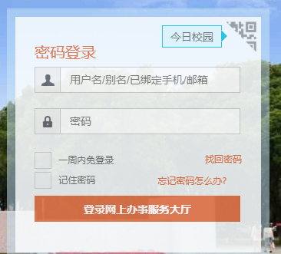

2、登陆后，点击then click“可用应用-研究生-我的论文开题应用”

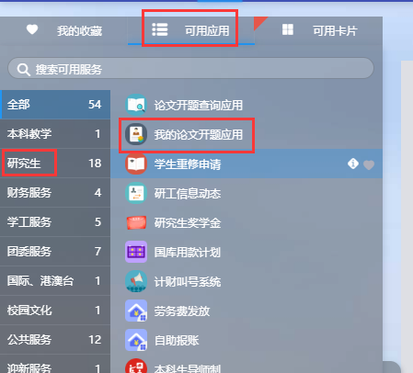

3、开题申请信息输入。“主要内容”可写开题报告正文，也可直接填“见附件”。开题考核表全文（包括开题报告正文为附件）以附件形式上传。

Fill the opening report information in the online form.

论文题目Thesis title

论文关键词Thesis key words

论文类型：学位论文

论文选题来源(the origin of your thesis choice): This choice can ask your supervisor

是否涉密(is it secret): 否（no）

论文预计开始时间 the estimated starting time of thesis

论文预计结束时间 the estimated ending time of thesis

主要内容 main content: your Opening report

附件attachment：Send your (1) Opening Report and (2) Opening Report Examination Form

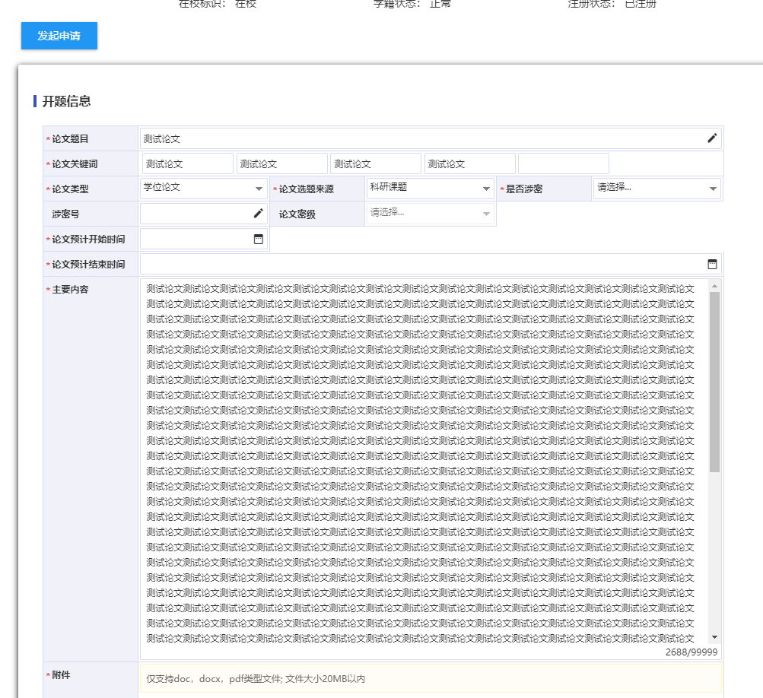

4、点击click“提交”。